WANNACRY OUTBREAK

What is Ransomware?
Then the program puts up a screen demanding you pay money to get access back. Typically the price increases over time until the end of a countdown, when the files are destroyed.

What is Wannacry Ransomware?
We first heard about WannaCry from the UK's health service, which appeared to be one of the first major computer systems affected by the hack. It's also called WannaCrypt.

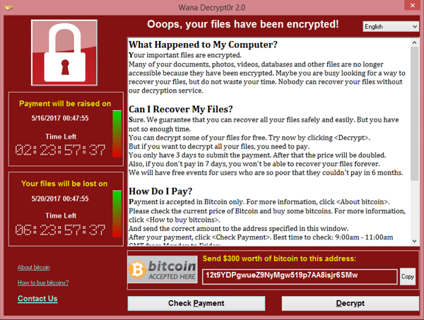

How do I protect my machine?
If you're running a Windows-powered PC, make sure all your software is up to date. In addition, as always, do not open suspicious emails, click on links you don't know or open any files you weren't expecting.

What do I do if my computer is infected?
So far, there doesn't appear to be a proven way to fix WannaCry. Cyber security researchers claim to have a method to stop it.

Shortly after WannaCry began to spread, a security researcher accidentally found a kill switch that appeared to stop WannaCry in its tracks. But hackers have since made a fix, and this time there doesn't appear to be any way to stop it. It also has a new name Uiwix, according to researchers at Heimdal Security.

Another diabolical twist is if the ransom isn't paid in 72 hours, the price could double. And after a few days, the files are permanently locked.

Great, so I have to pay these monsters to get my computer back?
While there is no clear fix for WannaCry, experts highly recommend you not pay to get your data back.

While it may be tempting to fork over the $300 ransom to make the problem go away the FBI, Department of Justice and many tech firms suggest you don't. One reason is that you're basically giving money to criminals, who may demand even more money or potentially re-target you in the future since you've indicated you're willing to pay them in the first place.

What is this bitcoin stuff the hackers want us to pay with?
Hackers typically demand payment via bitcoin, an untraceable digital currency often used on shadowy parts of the internet. While it's hard to trace, the amount of money that's been sent to the criminals is public information.

Ok, so if I don't pay, what can I do if I'm infected?
Many experts say wiping your machine and restoring from backups is a better way to go. If you don't have regular backups of your data, I'm sorry to say you're in a real bind.

Who created WannaCry?
The hack appears to have originally been discovered by the National Security Agency (NSA), which allegedly kept it on file as a potential tool to use for surveillance or other issues.

Does WannaCry affect my Mac, iPhone or Android?
No. It appears to only affect computers powered by Microsoft Windows. Microsoft released a software update in March that protects against this vulnerability, but we've since learned that many people didn't update their computers.
Who's most vulnerable?
Windows-powered PCs that aren't running updated software that protect from this vulnerability are the most at risk. WannaCry appears to travel across corporate networks, spreading quickly through file-sharing systems.

The diabolical part of that is corporate computers are typically controlled by IT departments that choose when to send updates to computers. So if one computer is vulnerable, it's likely all the computers on a corporate network are too, making it easy for WannaCry to have a large impact.

How does WannaCry spread?
It appears networks of computers, like schools, companies, hospitals and businesses, are particularly vulnerable. That's because security researchers say the ransomware is spread through standard file sharing technology used by PCs called Microsoft Windows Server Message Block, or "SMB" for short.

It also appears able to spread to other computers outside corporate networks. Researchers have already found variants of the attack, so there isn't just one way it works.

What do I do if I'm not hit but worried I might be?
If you have backups, now would be a good time to update them. If you don't, I suggest you start.

Also make sure to check your software updates and talk to your IT managers.

Please watch the following video for more understanding:
https://www.youtube.com/watch?v=cZ543_0bjbw

